Sociology Reading List

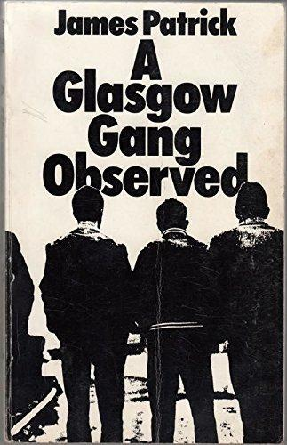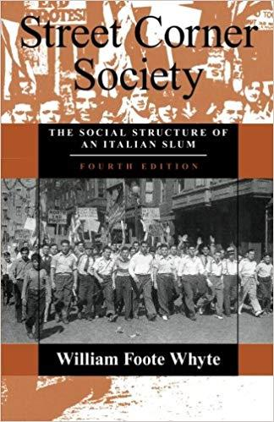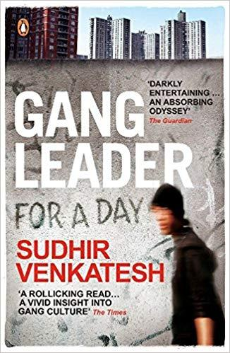

**Textbooks/Reference**

* Brown, K. AQA A Level Sociology Book One and Two, and Revision Guide.
* Haralambos ,M. AQA A level Sociology Themes and Perspectives, Year 1 and AS and Year 2

***

**An amazing place to go for lots of reading lists:**

<https://port.rl.talis.com/courses/u0315pyc.html>

<https://port.rl.talis.com/courses/c0979s.html>

<https://port.rl.talis.com/courses/c1586s.html>

<http://lib5.leeds.ac.uk/rlists/broker/readinglists.php?s=l&q=slsp&scope=2&sess=202021>

<http://lib5.leeds.ac.uk/rlists/broker/readinglists.php?q=GEND&sess=201920>

***

**Books**

***Gender (so many I could write here!!)***

* Adichie, C (2014) We should all be Feminists : <https://people.unica.it/aideesu/files/2019/11/Chimamanda_Ngozi_Adichie_We_Should_All_Be_Feminiz-lib.org_.epub_.pdf>
* Beard, M. (2017). Women & Power.
* Butler, J (2006) Gender Trouble.
* Connell, R.W. and Pearse, R. (2014). Gender (3rd edition).
* Connell, R.W (2006) Masculinities.
* Curtis, S (2020) Feminists Don’t Wear Pink.
* Criado-Perez, C (2020) Invisible Women: Exposing Data Bias.
* De Beauvoir, S (1949) The Second Sex.
* Fine, C (2005) Delusions of Gender: The Real science behind sex differences.
* Freidan, B (1963) The Feminine Mystique.
* Gay, R (2014) Bad Feminist.
* Greer, G (1970) Female Eunuch.
* Levy, A (2006) Female Chauvinist Pigs.
* Orbach, S (2009) Bodies.
* Walter (2011) Living Dolls: The Return of Sexism.
* Wolf (1991) The Beauty Myth.
* Wollstonecraft (1970) A Vindication of the rights of a woman.

***General***

* Baudrillard, J (2017) The consumer society: myths and structures.
* Bauman, Z. (2000). Liquid modernity.
* Bauman, Z (2005) Work, consumerism and the new poor.
* Bauman, Z (2007) Consuming Life.
* Bauman, Z. and May, T. (2019) Thinking Sociologically.
* Becker, H (1963) Outsiders.
* Bourdieu, P (2010) A Social Critique of the judgment of taste.
* Bryman, A. (2012) Social Research Methods (4th Edition).
* Cohen, R and Kennedy, P (2007or the latest edition), Global Sociology.
* Downes, D and Rock P (2007) Understanding Deviance: A guide to the sociology of rule breaking.
* Featherstone, M (2007) Consumer culture and Postmodernism.
* Foucault, M (1975) Disciple and Punish.
* Giddens, A. and Sutton, P. (2017) Essential Concepts in Sociology.
* Goffman, E (1959) The Presentation of Self in Everyday Life.
* Hartley, D. (eds) (2019) Social Policy (Short Introductions), 3rd edition.
* Jones, O (2011) Chavs.
* Jones, O (2015) The Establishment.
* Lemert, C. (2011) Social Things: An Introduction to the Sociological Life, 5th ed.
* Liebling, A., Maruna, S., and Reiner, R. (2017) The Oxford Handbook of Criminology (6th Ed).
* Luckmann, T and Berger, P (1991) The Social Construction of Reality.
* Matza, D (1964) Deliquency and Drift.
* McLaughlin, E. and Muncie, J. (2019) The SAGE Dictionary of Criminology (4th Ed).
* Mills, C.W (1959) The Sociological Imagination.
* Moore, S. et al. (2010) The Ultimate Study Skills Handbook.
* Newburn, T. (2017) Criminology (3rd Ed).
* Plummer, K. (2016) Sociology: The Basics.
* Ritzer, G (2005) Enchanting a disenchanted world.
* Ritzer, G (1998) McDonaldisation.
* Scott, J. (2014) A Dictionary of Sociology.
* Walklate, S (. ) Criminology: The Basics.
* Weber, M. (2001) The Protestant Ethic and the Spirit of Capitalism.
* Veblen, T (1970) The theory of the leisure class.
* Zuboff, S. (2019). The Age of Surveillance Capitalism.

***Marxism and Marxian Analysis***

[marxists.org](http://www.marxists.org/archive/)

<http://users.sussex.ac.uk/~sefd0/bib/marx.htm>

Marx

* Karl Marx and Friedrich Engels. Collected Works. (1975)
* Karl Marx and Friedrich Engels. Selected Works, 2 Volumes. (1962)
* Secondary Literature
* Louis Althusser. [For Marx](https://en.wikipedia.org/wiki/For_Marx). (2005)
* Louis Althusser and Étienne Balibar. [Reading Capital](https://en.wikipedia.org/wiki/Reading_Capital). (2009)
* Jacques Attali. Karl Marx or the thought of the world. (2005)
* Schlomo Avineri. The Social and Political Thought of Karl Marx. (1968)
* Kostas Axelos. Alienation, Praxis, and Techne in the Thought of Karl Marx (1976).
* Paul Blackledge. Reflections on the Marxist Theory of History (2006)
* Paul Blackledge. Marxism and Ethics (2012)
* Tom Bottomore, (ed) A Dictionary of Marxist Thought. (1998)
* Alex Callinicos. The Revolutionary Ideas of Karl Marx. (2010)
* Harry Cleaver. Reading Capital Politically (2000)
* Gerald A. Cohen. Karl Marx's Theory of History: A Defence (1978)
* Andrew Collier. Marx (2004)
* Hal Draper. Karl Marx's Theory of Revolution. 4 volumes. (2015)
* Terry Eagleton. Why Marx Was Right (2011).
* Ben Fine. Marx's Capital. 5th ed. (2010).
* John B. Foster. Marx's Ecology: Materialism and Nature. (2000).
* David Harvey. A Companion to Marx's Capital.  (2010)
* David Harvey. The Limits of Capital. (2006)
* Michel Henry. Marx I and Marx II. (1976)
* Antonio Gramsci. Prison Notebooks. (1999)

“Post-Marx” Marxian Analysis

* Frankfurt School: Introduction
* Paul Connerton. Critical Sociology. (1976)
* David Held. Introduction to Critical Theory: Horkheimer to Habermas. (1980)
* Martin Jay. The Dialectical Imagination: A History of the Frankfurt School and the Institute of Social Research (1996)

Keystone Publications:

* Herbert Marcuse. Reason and Revolution. (1941)
* Walter Benjamin. The Work of Art in the Age of Mechanical Reproduction. (1936)
* Max Horkheimer. Eclipse of Reason. (1947)
* Erich Fromm. Escape from Freedom. (1941)
* Theodor Adorno and Max Horkheimer. Dialectic of Enlightenment. (1947)
* Theodor Adorno. Minima Moralia. (1951)
* Herbert Marcuse. Herbert Marcuse. Eros and Civilization. (1955)
* Herbert Marcuse. One-Dimensional Man (1964)
* Theodor Adorno. Negative Dialectics. (1966)

Habermas

* Knowledge and Human Interests. (1971)
* Theory and Practice. (1973)
* Legitimation Crisis. (1975)
* Communication and the Evolution of Society. (1979)
* The Theory of Communicative Action. (1984; 1987)
* The Philosophical Discourse of Modernity. (1985)
* The Logic of the Social Sciences. (1988)
* The Structural Transformation of the Public Sphere. (1989)
* Moral Consciousness and Communicative Action. (1990)
* Structural Transformation of the Public Sphere. (1991)
* Justification and Application. (1993)
* Between Facts and Norms. (1996)
* The Postnational Constellation. (2001)

***

**Magazines and Journals**

* Sociology Review
* National Geographic
* Guardian Society (Wednesdays)
* The Economist

***

**Websites**

* LSE Researching Sociology Blog
* [www.educationforum.co.uk/sociology](http://www.educationforum.co.uk/sociology)
* www.sociology.org.uk <http://www.aqa.org.uk/qual/gce/sociology>
* <http://www>.s-cool.co.uk
* http://www.statistics.gov.uk/glance/ Sociology Resources
* http://www.ruthssociology.com/
* Social Science Information Gateway (Sociology)
* [www.sosig.ac.uk/sociology](http://www.sosig.ac.uk/sociology)
* <https://www.thesociologicalreview.com/blog/a-fiction-and-sociology-readinglist>
* <http://www.socanth.cam.ac.uk/media/listen-and-view/camthropod>
* https://aeon.co/society
* https://www.tutor2u.net/sociology/reference  
  <http://politybooks.com/kenbrowne/resources.asp>
* https://napierpress.com/book-one-workbooks
* https://napierpress.com/book-two-workbooks
* <http://www.earlhamsociologypages.co.uk>
* https://www.sociologystuff.com

***

**Podcasts**

* The Guilty Feminist (Deborah Francis-White)
* Women of the Hour (Lena Dunham)
* Revisionist History by Malcolm Gladwell – search for episodes on racism and poverty in education (Series 1, episodes 4 and 5) (Series 2, episodes 3 and 4)
* BBC ‘The Missing Cryptoqueen’ – great links to crime and globalisation.
* Radiolab - not all of these will be relevant. However, episodes like Eye in the Sky covers surveillance, have been episodes on human trafficking and in the series ‘G’ they covered how IQ tests discriminated against EM children in schools in the US.
* Freakonomics - again, not all of these will be relevant. But, 'Did China eat America's jobs?' covers globalisation, 'Why are we still using cash?' is relevant to crime, there was an episode on racial profiling of restaurant staff...
* TED talks - Again, it's a case of searching topic by topic but, Glenny did one on transnational organised crime.
* Planet Money.
* 99% invisible
* [Thinking Allowed on Radio 4](https://www.bbc.co.uk/programmes/b006qy05)
* [Social Science bites](https://www.socialsciencespace.com/about-socialsciencebites/)
* [Surviving Society](https://soundcloud.com/user-622675754)

***

**Movies and Documentaries**

* The Truman Show
* The Circle
* Louis Theroux Documentaries